Chapter 4, Problem 19.

Use superposition to solve for v_{x} in the circuit of Fig. 4.87.

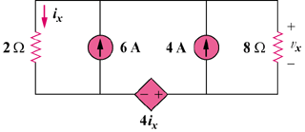

Figure 4.87
For Prob. 4.19.

